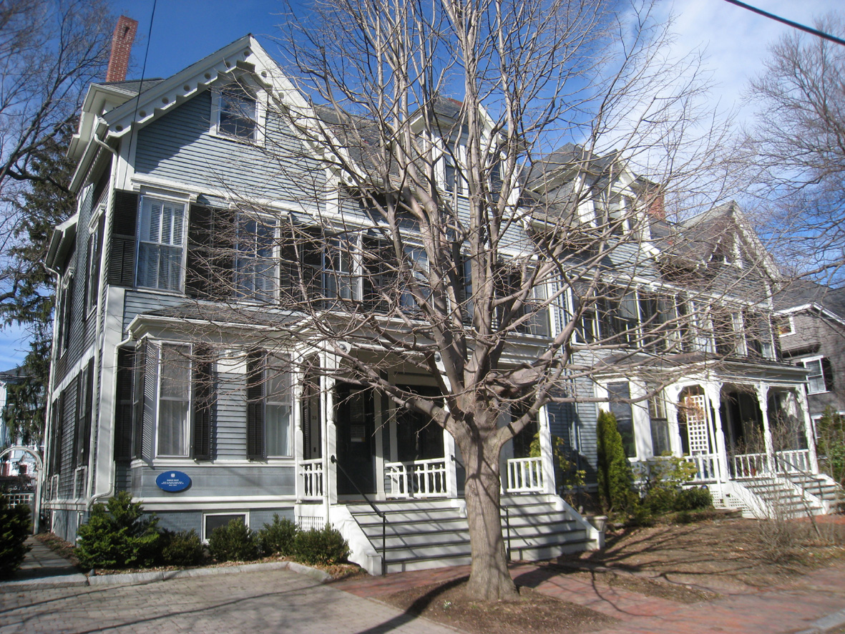
29-35 Brewster Street, Cambridge, Massachusetts

